ANL 501

End of Course Assessment

Data Visualization and Storytelling

Wang Yi Ming

E2510862

Date: 24 February 2025

# This report is fully generated by R-Markdown except this page

From Past to Present: An Analytical Overview of Singapore’s Parliamentary Elections

Wang YiMing E2510862

2025-02-24

# Executive Summary

This is a data-centric study of Singapore’s parliamentary elections between 1955 to 2020, including a strong focus on trends in political competition, vote share, and electoral outcome. Using data from past elections, the study uncovers the behavioral tendencies and results of parties at the central level and at the constituency level.

By analyzing the number of political parties competing throughout time, there was an early surge in the 1950s and 1960s, followed by a sharp decline in the 1970s and 1980s, dates in which a lot of parties dissolved and there were electoral reforms. The resurgent interest in the 2010s points to broad political diversity and revived participation.

The distribution of votes across parties highlights PAP’s longstanding dominance, with opposition parties gradually gaining a more substantial share. As reflected in the growing number of votes garnered by alternative parties, the Workers’ Party (WP) and other opposition factions have made steady gains while PAP continues to attract the most votes by far.

On the other hand, data on performance of PAP shows a declining trend in vote shares for PAP in the last few decades, with peaks in 1960’s and 1980’s followed by a decline in 2011 elections, blamed on dissatisfaction among voters about housing policies and cost of living issues. The PAP’s revival in 2015, driven by national sentiment after Lee Kuan Yew’s death, was short lived as vote share slipped again in 2020 amid intensifying political competition.

More insight into election competitiveness comes from the number of constituencies won by parties. From the 1960s to the 1980s, the PAP dominates most constituencies, but by 1991 and afterwards, opposition parties made inroads, winning seats in contested areas. The WP held on to Aljunied GRC and won GRC-elect Sengkang in the 2020 elections, testament to a maturing, competitive electoral landscape.

Geospatial maps of winning parties by constituency (2006-2020) further highlights the changes in political control. Although PAP holds three-fourths of the electoral map, opposition gains in the localities show voter preferences are changing, and alternative voices in politics are becoming more viable.

These findings indicate that even though PAP is still the single greatest power and influence in Singapore’s political landscape, there is some evolution occurring. The increasing success of opposition parties, combined with changing voter attitudes, points to a more competitive and dynamic electoral future.

# Introduction

## Background

Singapore’s parliamentary elections have been a staple of the nation’s political history since its first elections in 1955. Over the decades, elections have played a vital role in shaping the political direction of the country, with the People’s Action Party (PAP) historically dominating the scene. But in recent years, the tide seems to have changed. The opposition has made stronger inroads, and Prime Minister Lawrence Wong has admitted that PAP can no longer take for granted “safe seats” in the next elections (Elections Department Singapore, 2020).

## Objectives of the Study

This report seeks to provide an analytical overview of Singapore’s parliamentary elections from 1955 to the present, using data-driven insights. The key objectives are:

1. To track the number of political parties contesting over time.
2. To analyze the distribution of votes across different parties.
3. To observe trends in political parties’ performance and how they have evolved.
4. To examine changes in the number of seats won by different parties.
5. To visualize electoral boundary changes over time using geospatial data.

## Data Sources and Preprocessing

This study is based on official data from the Elections Department (ELD) of Singapore, accessed via the data.gov.sg API. Before conducting any analysis, the datasets need to be checked for discrepancies and cleaned accordingly. Some of the datasets used are as follows:

1. Parliamentary General Election Results by Candidate

## Rows: 1,539  
## Columns: 8  
## $ `_id` <int> 1, 2, 3, 4, 5, 6, 7, 8, 9, 10, 11, 12, 13, 14, 15, 1…  
## $ year <chr> "1955", "1955", "1955", "1955", "1955", "1955", "195…  
## $ constituency <chr> "Bukit Panjang", "Bukit Panjang", "Bukit Timah", "Bu…  
## $ constituency_type <chr> "na", "na", "na", "na", "na", "na", "na", "na", "na"…  
## $ candidates <chr> "Goh Tong Liang", "Lim Wee Toh", "S. F. Ho", "Lim Ch…  
## $ party <chr> "PP", "SLF", "PP", "PAP", "SLF", "DP", "SLF", "PP", …  
## $ vote_count <chr> "3097", "1192", "722", "3259", "924", "1308", "3305"…  
## $ vote_percentage <chr> "0.7221", "0.2779", "0.1162", "0.5245", "0.1488", "0…

This dataset includes election results for various constituencies across different years, containing candidate names, political parties, votes received, and vote percentages. Issues identified include “na” values in the vote_count and vote_percentage columns, a non-numeric year column, and an unnecessary _id column. Since votes are not counted in uncontested constituencies in Singapore, “na” in vote_count was replaced with 0, while “na” in vote_percentage was set to 1. The year column was converted into an integer format, and _id was removed for clarity.

1. Parliamentary General Election Dates

## Rows: 16  
## Columns: 4  
## $ `_id` <int> 1, 2, 3, 4, 5, 6, 7, 8, 9, 10, 11, 12, 13, 14, 15, 16  
## $ year <chr> "1955", "1959", "1963", "1968", "1972", "1976", "1980",…  
## $ nomination_day <chr> "2/28/1955", "4/25/1959", "9/12/1963", "2/17/1968", "8/…  
## $ polling_day <chr> "4/2/1955", "5/30/1959", "9/21/1963", "4/13/1968", "9/2…

This dataset provides key election dates, including nomination and polling days. Issues identified include the year and dates columns being stored as text. To resolve this, the year was converted into an integer, and both nomination_day and polling_day were standardized to a proper date format. Additionally, the _id column was removed for readability.

1. List of Political Parties

## Rows: 39  
## Columns: 3  
## $ `_id` <int> 1, 2, 3, 4, 5, 6, 7, 8, 9, 10, 11, 12, 13, 14, 15, 16,…  
## $ abbreviation <chr> "AI", "BS", "CP", "DP", "DPP", "JPS", "KURA", "LP", "L…  
## $ political_party <chr> "Angkatan Islam Singapura (Angkasa)", "Barisan Sosiali…

This dataset contains political party names along with their abbreviations. The only issue found was the presence of an unnecessary _id column, which was removed for clarity.

The Data Appendix provides full details of the data cleaning process.

# Analysis & Insights

## 1. The number of political parties over time

The evolution of Singapore’s political landscape can be explored through the number of parties that stood for election during parliamentary elections held. The graph below is a representation of the number of parties contesting each General Election, the 1950s to 2020.

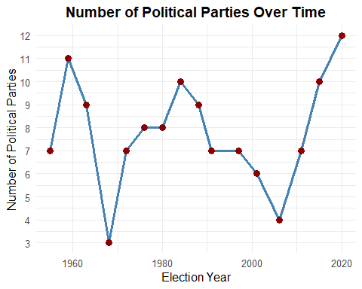

### Observations from the Line Chart

#### Early Surge (1950s – 1960s):

In the earliest elections, from about 1955 only a few political parties were involved. But, in subsequent election cycles, the number of parties exploded in 1959, matching a time of intense political action as upstart formations sought to put their stamp on the country’s course.

#### Significant Dip (Late 1960s – 1980s):

Shortly after that initial surge, the trend reversed sharply. By the chart’s end point in 1968, this had dropped to only three parties contesting that election. Several factors, including mergers and dissolutions, contributed to the reduced diversity in party representation. In the 1970s and early 1980s, the data shows moderate variation in effective numbers of parties, generally between seven and eight parties. The People’s Action Party continued to dominate, but there were entries and exits of smaller parties that kept the overall count low and relatively stable during that period.

#### Fluctuations ( Mid 1980s – 2000s):

That number then started to climb again in the mid-1980s. However, between 1984 and 2006, there was a steady reduction in the number of political parties. This period indicates that this phase reflects that factors like electoral reforms, strategic consolidations, and the peculiarities faced by fairly new parties that may have led to the dipping of diversity in participation and cemented the control of established political actors.

#### Recent Uptick (2010s – 2020):

The number of parties began to rise again, peaking at about a dozen parties competing in the 2020 elections. This recent upswing can be seen as a re-opening of the political arena, where smaller and emerging groups are revving up once again. It indicates a political terrain that is shifting.

## 2. The distribution of votes across parties

To understand the political landscape in Singapore, it is useful to see how votes are divided among different parties. The bar chart below compares the top three parties (plus a consolidated “Other” category).

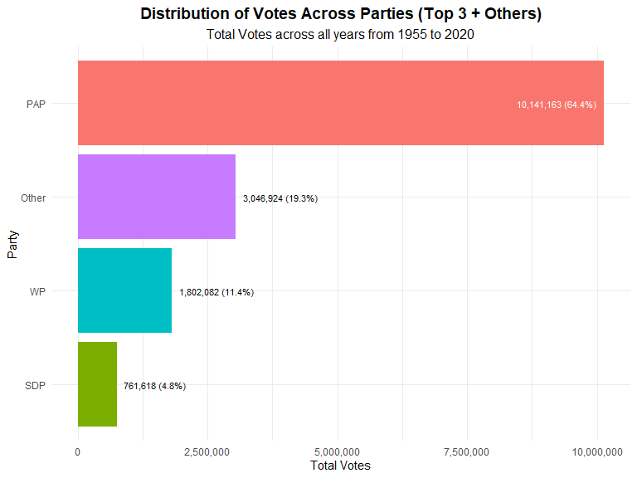

### Observations from the Bar Chart

This shows the People’s Action Party(PAP) owned the highest share of votes around 64.4 percent. The result was a reminder of the party’s long-established claim to being the dominant force in local politics. However, the remaining votes are more widely spread than one might expect.

The “Other” total includes many smaller parties, as no other single party receives as many votes as the PAP’s on its own, but this category combined represents just about one-fifth of all votes (19.3 percent) in aggregate, indicating that multiple parties besides the PAP together actually garner a substantial element of public support. The next largest opposition party is the Workers’ Party (WP) with 11.4 percent, followed by the Singapore Democratic Party (SDP) with 4.8 percent. These numbers suggest that voters do contemplate options other than the governing party, but also that their preferences are varied among multiple different groups.

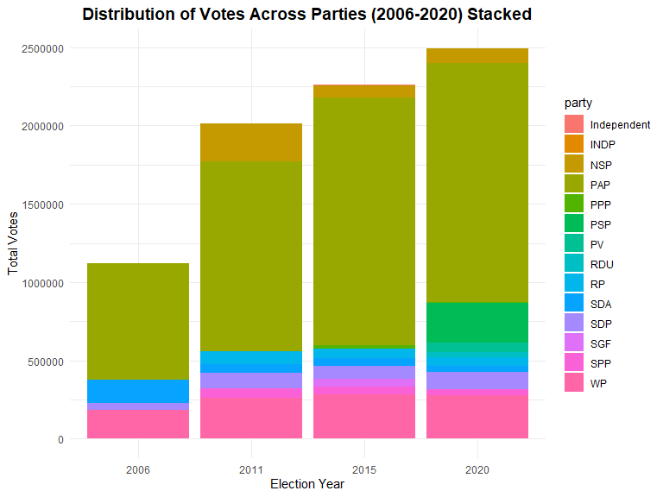

### Oberservations from the Stacked Bar Chart

In the stacked bar chart from 2006 to 2020, the total height of each bar is the number of votes cast; each shade of color shows the contribution that party made to that total. In fact, even through all four elections, the People’s Action Party (PAP) is seen to occupy the largest segment, indicative of its continued presence at the polls. However, the chart also shows the existence and increasing scale of other parties; in this case, the Workers’ Party (WP), which is consistently represented by a visible proportion in the bottom exceeding part of each column.

From 2006 to 2020, the number of total votes increases almost steadily — implying greater voter engagement over time. Besides, new parties join the later elections, like the Progress Singapore Party (PSP) in 2020, making the chart multiple layer and complicated.

## 3. Trends in PAP’s Performance

The People’s Action Party (PAP) has remained the dominant political party in Singapore after the country’s first general elections in 1955. However, its vote share has fluctuated over time, reflecting changes in the political landscape, voter sentiment, and key historical events. The line chart below depicting PAP’s vote share from 1955 to 2020 highlights these trends and provides insights into the evolution of electoral support for the ruling party.

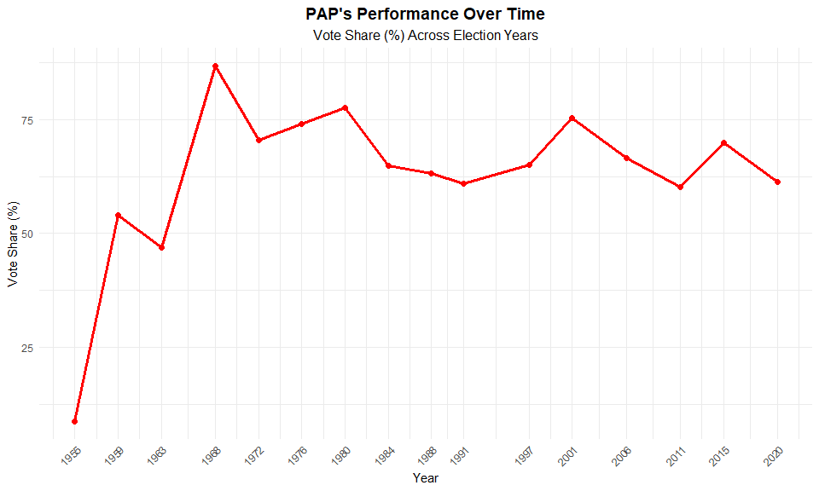

### Obervations from the Line Plot

In the initial years, the vote share of PAP increased significantly, peaking above 80% during the 1968 elections. This was during the time of Singapore’s independence in 1965, when good governance was considered indispensable for stability and development. In 1968, such overwhelming support reflected the weakened state of the opposition, with multiple parties boycotting the election in protest against PAP’s dominance..

During the 1970s and early 1980s, PAP retained a supermajority, even as its share of the vote slowly decreased. By the 1984 elections, opposition parties were beginning to make inroads, with the Workers’ Party winning a seat in Parliament for the first time in decades. It was also the beginning of a gradual but sustained rise in political competition.

PAP’s vote share fluctuated between 60% and 75% in the late 1990s and early 2000s. The 2011 general elections, however, were one of the party’s steepest declines ever when its vote share fell to some 60%. This marked a shift in priorities, mirroring increasing public anxiety regarding matters such as the cost of living and housing affordability and the consequences of foreign labor policies. The opposition’s success in securing a Group Representation Constituency (GRC) for the first time was an indication of a more competitive political landscape (Chin, 2012).

This dip was followed by PAP recovering some ground in the 2015 elections, increasing its vote share to almost 70%. This rebound was helped by a strong national mood after the death of Singapore’s founding prime minister, Lee Kuan Yew, earlier in the year. But in the 2020 elections, PAP’s share of the vote fell again to almost 61 per cent, pointing to there being room for increased political diversity, and a stronger willingness on the part of voters to support other parties.

In summary, while the PAP has enjoyed a majority of voter support through the years, electorate demeanor has changed over time, influenced by various factors such as economic conditions, social policies and political developments.

## 4. Changes in the number of Constituency won by parties

The number of constituencies that political parties won in general elections in Singapore reveals the level of electoral competition through time. The stacked bar chart below gives an overview of the overwhelming strength of the People’s Action Party (PAP) in terms of parliamentary seats won in each election cycle, as well as of how successful opposition parties were.

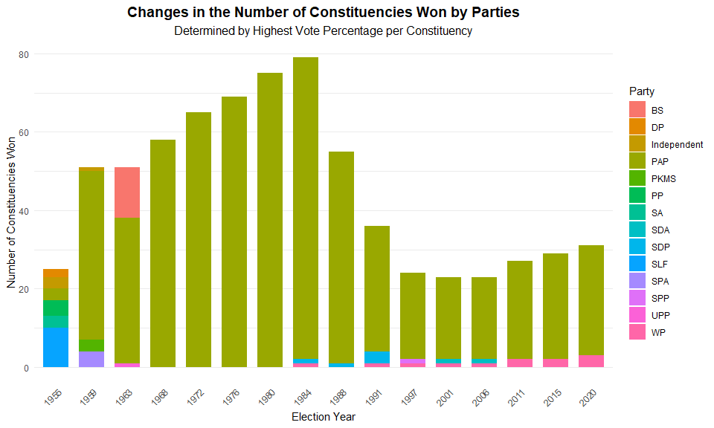

### Observations from the Stacked Bar Chart

The 1955 general elections did not result in PAP gaining full government control. Singapore was still under British rule at this point, and the Labour Front, led by Chief Minister David Marshall, place first in terms of seats won and headed up the government. It only won a handful of constituencies in this election, but gained power swiftly in the following years. In 1959, PAP won a decisive number of seats and became Singapore’s first fully-elected government, which was the beginning of PAP’s political hegemony.

From the 1960s to the mid-1980s, PAP saw an increasing and near-complete hold over constituencies. The 1968 elections, in particular, saw PAP winning almost all constituencies as opposition parties boycotted the election. This trend continued into the 1970s and 1980s, with PAP winning nearly all available seats, peaking in 1980 and 1984 when it secured close to complete control of Parliament.

However, the 1991 general elections marked a change in the political calculation, with opposition partiest capturing a significant number of constituencies. From 1997 to 2011, the opposition continued to make small but steady gains, challenging PAP in select constituencies.

The 2011 and 2020 elections further highlight this shift. Even though PAP was still the ruling party, it would seem the opposition parties, and more so the Workers’ Party, made significant advances. The 2011 general election was historic as it was the first time an opposition party captured a Group Representation Constituency (GRC) when the Workers’ Party won Aljunied GRC. This trend was cemented in the 2020 elections, revealing that voters were becoming more willing than ever to back opposition candidates in contested constituencies.

## 5. Winning Party By Constituency (2006 - 2020)

From 2006 to 2020, these electoral maps paint an immediate picture of political dominance across the constituencies in Singapore. Each map highlights the winning party in each electoral division, showing shifts in political control and the geographical spread of opposition strongholds.

### 2006: Near Total Dominance by PAP

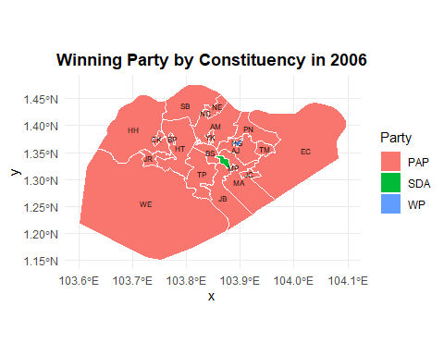

The People’s Action Party (PAP) of Singapore won almost all constituencies in 2006, the map is almost all a uniform red color. Only two constituencies were not held by the PAP: one won by the Workers’ Party (WP) (blue) and another by the Singapore Democratic Alliance (SDA) (green). This election maintained the PAP’s entrenched dominance, with opposition gains remaining localized and limited in scope.

### 2011: A Turning Point for the Opposition

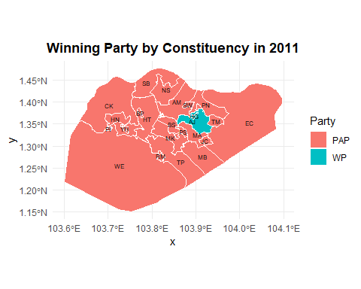

The 2011 general election was a turning point in Singapore’s electoral history. WP expanded its influence, capturing Aljunied Group Representation Constituency (GRC) for the first time, which is a major breakthrough as being the first opposition win in a GRC system, which was seen as favoring larger parties like PAP, its victory represented a significant shift at the ground level. This election was seen as a response to growing public concerns over issues such as the rising cost of living and housing policies. The map for 2011 shows this effect, with a larger blue area, representing WP’s growing dominance than in 2006.

### 2015: Stabilization of Opposition Gains

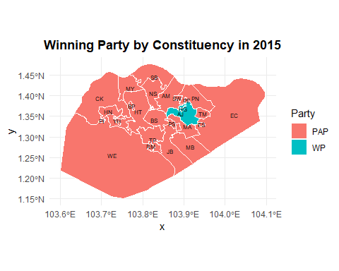

In 2015, WP retained its stronghold in the Aljunied GRC, as well as the Hougang single member constituency (SMC). All in all, the electoral map looks similar to 2011 and although the opposition is not gaining ground, it’s maintaining ground. The elections occurred in the immediate aftermath of the passing of Singapore’s founding Prime Minister, Lee Kuan Yew, and votes were presumably affected by national feelings.

### 2020: The Most Competitive Election Yet

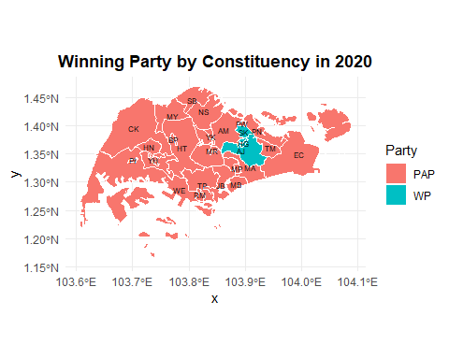

By the time of 2020, the opposition was in an even stronger position. WP held on to Aljunied GRC and Hougang SMC in that election, and gained Sengkang GRC — another historic win for the oppositiion. This shift is clearly visible on the 2020 map, where the increased blue area reflects WP’s continued electoral success. The PAP still maintained overall dominance, but Singaporean voters were showing an increasing willingness to throw their support behind the opposition parties come 2020.

# Conclusion

Singapore’s electoral history is a record of both continuity and change. And although the People’s Action Party has ruled since 1959, data reveals a gradual shift in voter sentiment and increased competition. After the initial flood of parties following early elections, there was a consolidation period during which PAP tightened its grip. But, from the 1980s, opposition parties slowly solidified their ground,with unprecedented victories in the 2011 and 2020 elections.

The study of vote distribution and constituency outcomes is further examination of this trend. Though PAP maintains a predominant share of votes and constituencies, opposition parties have enjoyed impressive gains, especially in urban sectors. The rise in contested seats and retention of opposition party strongholds is an indication the electorate’s expectations and preferences are changing.

Looking ahead, the data suggests that future elections may be even more competitive. As political diversity grows and voters become more receptive to alternative parties, the notion of “safe seats” may become less relevant. The evolving political landscape indicates that Singapore’s elections are no longer a one-sided affair but a reflection of a more engaged and discerning electorate. This shift presents opportunities and challenges for all political parties as they adapt to changing voter sentiments in the years to come.

# Data Appendix

## Data Cleaning and Preprocessing

Besides converting non-numeric year columns to integer format, managing missing values in vote counts and percentages and dropping useless columns such as _id in datasets. I need to combine datasets to match up election results with party affiliations and create new variables to generate visualisations.

### Data Cleaning for The number of political parties over time

To plot the “The number of political parties over time”, we have to group the df.elections_cleaned by year, this will cause calculations to be performed separately by year of election. Then for each election year, the function n_distinct(party) will count the unique political parties that participated. This value is saved in a new column called num_parties. Lastly, we make a new dataframe “parties_over_time” to plot the line chart.

## # A tibble: 6 × 2  
## year num_parties  
## <int> <int>  
## 1 1955 7  
## 2 1959 11  
## 3 1963 9  
## 4 1968 3  
## 5 1972 7  
## 6 1976 8

### Data Cleaning for The Distribution of Votes Across Parties

To plot the “Vote Share of the Top 3 Political Parties and Others”, we first need to summarize the total votes received by each political party across all elections. This is done by grouping the dataset by party and summing up the total votes. Then, we identify the top 3 parties based on total votes and group all other parties into an “Others” category. The function fct_lump_n() automatically selects the top n = 3 parties and assigns the rest to “Others.” Finally, we calculate the vote share (%) of each group (Top 3 + Others) relative to the total votes cast. The cleaned data is stored in a new dataframe df_party_votes_lumped, which we will use for visualization.

## # A tibble: 4 × 6  
## party_lumped total_votes share label_color label_hjust fill_color  
## <fct> <dbl> <dbl> <chr> <dbl> <chr>   
## 1 PAP 10141163 0.644 white 1.1 #F8766D   
## 2 SDP 761618 0.0484 black -0.1 #7CAE00   
## 3 WP 1802082 0.114 black -0.1 #00BFC4   
## 4 Other 3046924 0.193 black -0.1 #C77CFF

To plot the “Distribution of Votes Across Parties (2006-2020) Stacked”, we first need to filter the dataset to include only elections from 2006 to 2020. This ensures we are analyzing the most recent election trends. Next, we group the dataset by both year and party to calculate the total number of votes each party received in each election year. We use the function sum(vote_count, na.rm = TRUE) to sum up the votes while handling any missing values. Finally, we store the processed data in a new dataframe df_votes, which will be used to create a stacked bar chart to visualize the vote distribution among parties over time.

## # A tibble: 6 × 3  
## year party total_votes  
## <int> <chr> <dbl>  
## 1 1955 DP 32115  
## 2 1955 Independent 15098  
## 3 1955 LP 1325  
## 4 1955 PAP 13634  
## 5 1955 PP 38695  
## 6 1955 SA 13157

### Data Cleaning for Trends in PAP’s Performance

To analyze PAP’s vote share trends, we first group the dataset by year and party to calculate the total votes received by each party per election. Next, we compute the total number of votes cast in each election year, allowing us to determine the vote share (%) for each party by dividing their total votes by the overall votes in that year. We then filter the data to retain only PAP’s vote share across elections.

## # A tibble: 6 × 5  
## year party total_votes year_total vote_share  
## <int> <chr> <dbl> <dbl> <dbl>  
## 1 1955 PAP 13634 156324 8.72  
## 2 1959 PAP 281891 521271 54.1   
## 3 1963 PAP 272924 581555 46.9   
## 4 1968 PAP 65812 75894 86.7   
## 5 1972 PAP 524892 745239 70.4   
## 6 1976 PAP 590169 796572 74.1

### Data Cleaning for Changes in the number of Constituency won by parties

To analyze the number of seats won by each party in elections, we first identify the winning party for each constituency by selecting the candidate with the highest vote percentage in every election year. This ensures that each constituency is assigned to a single winner. Next, we count the number of seats won per party per election year, grouping the dataset by year and party. This gives us a structured view of how many constituencies each party controlled in different elections. Finally, we convert the year column into a factor and order it chronologically.

## # A tibble: 6 × 3  
## year party seats  
## <fct> <chr> <int>  
## 1 1955 DP 2  
## 2 1955 Independent 3  
## 3 1955 PAP 3  
## 4 1955 PP 4  
## 5 1955 SA 3  
## 6 1955 SLF 10

### Data Cleaning for Winning Party By Constituency (2006 - 2020)

To map the electoral results, we first extract constituency names (ED_DESC) and codes (ED_CODE) from the Description column in the electoral boundary dataset. This allows us to standardize constituency names for merging with election results. Next, we identify the winning party for each constituency by selecting the candidate with the highest vote percentage. We ensure consistency by converting constituency names to uppercase, trimming spaces, and standardizing hyphen formatting to match boundary dataset formatting. After cleaning both datasets, we merge the electoral boundaries with the winners to create map_data, which links geographic shapes to winning parties. Lastly, we generate centroid points (st_point_on_surface()) for each constituency to allow label placement on the map without overlapping boundaries. Processed datas will not be shown here be shown here.

# References

Elections Department Singapore. (2020). Parliamentary General Election Results Dataset (1955–2020). Data.gov.sg. Retrieved from <https://data.gov.sg>

Singapore Elections Department. (2020). Electoral Boundaries Review Committee Report 2020. Retrieved from <https://www.eld.gov.sg>

Chin, J. (2012). Singapore’s 2011 General Election: Opposition Politics in the Internet Age. Asian Survey, 52(5), 813–833. <https://doi.org/10.1525/as.2012.52.5.813>

# Full R-Markdown Codes

